Lab Assignment 8
Stepan Shkrobak
Dr. Michael Bartolacci
IST 894, Section 001: Capstone Experience,
22 March 2026

Table of Contents
Table of Contents 1
General Context 2
Technical Context 3
Screenshots 5
References 12

General Context
The Network Security and Diagnostics lab focused on how network infrastructure can be monitored and controlled to protect systems from unauthorized access. There was a focus on firewalls and how they can serve as checkpoints to inspect traffic entering or leaving a network. Firewalls are widely recognized as a foundational network security control, as the National Institute of Standards and Technology notes that firewalls enforce security policies by monitoring and controlling incoming and outgoing network traffic based on predetermined rules (NIST, 2023). Defining rules for the firewall helps it know what to allow and what to block, allowing administrators to reduce the risk of unauthorized access and limit exposure to malicious actors. This helps administrators ensure that only services, systems, or protocols are permitted to access certain areas of a network, while potentially harmful or just specifically unapproved traffic is blocked.
The lab also covered the ability to analyze and troubleshoot network behavior. Diagnostic tools can help security professionals or administrators see communications on a network to identify active hosts, as well as see open services that may present vulnerabilities. It is almost like tracking a package throughout its shipment process, which allows one to easily identify where a problem might have arisen. Being able to overall understand a network and see the potential security concerns or weaknesses allows professionals to patch the vulnerability or have plans in place for exploitation of that vulnerability if it is chosen to access the vulnerability.
The Cryptography lab covered how sensitive information can be protected. According to the Cybersecurity and Infrastructure Security Agency, encryption plays a critical role in protecting sensitive data by ensuring that information remains unreadable to unauthorized users even if it is intercepted during transmission (CISA, 2022). Steganography, for example, was presented where a message was hidden within an ordinary photo file, which cannot actually be seen in the photo, but is embedded within the file. Encryption was also shown, where data can be locked up and only accessed by those with a key to that data. The lab also covered hashing and digital signatures, which allow users to verify data integrity and confirm the identity of the sender or ensure data was not changed during transit. These are usually ways organizations can protect data to maintain the confidentiality and integrity of data.

Technical Context
The Network Security and Diagnostics lab covered the monitoring and controlling of network traffic in order ot protect systems from unauthorized access. Modern network security architectures rely heavily on firewalls to inspect and filter network traffic, and Cisco explains that firewalls enforce access control policies by examining packets and allowing or denying traffic based on defined security rules (Cisco, 2023). Control policies were well covered in the lab as it focused on configuration and analysis of firewall behavior using iptables. Firewall configurations were looked at using commands like sudo iptables -S and sudo iptables -L, which showed the rule sets and default chain policies. Administrators can configure rules to allow only specific traffic, such as HTTP (port 80) or DNS (port 53), while blocking other communications with commands such as iptables -P OUTPUT DROP.
Additionally, using commands like ifconfig and route allowed the examination of network interface configurations and routing tables to determine a system’s IP address, subnet, and default gateway. Connectivity testing and host discovery were done using ping to test ICMP reachability and nmap to scan hosts for open ports and running services. Also, commands like nmap 192.168.1.100 -p80,443 were used to see whether web services were accessible through the firewall. Then curl allowed testing of HTTP or HTTPS responses from servers, while traceroute was used to see the path packets take across a network. This overall allows us to examine the network behavior, identify potential misconfigurations or exposed services that could become targets for attackers.
The cryptography lab covered ways used to protect the confidentiality, integrity, and authenticity of digital information as encryption is a fundamental mechanism for protecting digital communications, and Cloudflare explains that encryption converts readable data into ciphertext so that only parties with the correct decryption key can access the original information (Cloudflare, 2023). The lab demonstrated both symmetric and asymmetric cryptographic techniques using the OpenSSL command-line utility. Symmetric encryption examples included decrypting ciphertext files using commands such as openssl enc -d -aes-256-cbc -in aes-cbc.enc -out aes-cbc.txt, while asymmetric encryption involved generating RSA key pairs using openssl genrsa -out private_key.pem 2048 and encrypting files with a public key. Steganography was also covered where hidden information like text was extracted from image files using the steghide extract command. Finally hashing and digital signatures were covered, where hash functions such as SHA-256 were generated with commands like openssl dgst -sha256 file.txt to which can then be used to compare to an “original” hash to ensure the file has not been changed.

Screenshots
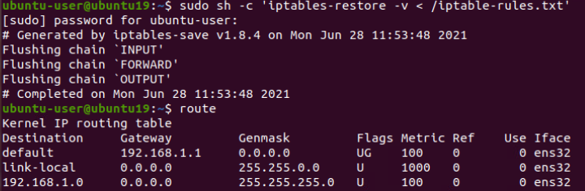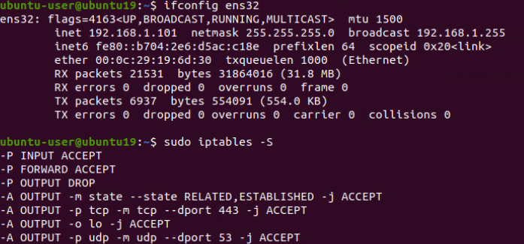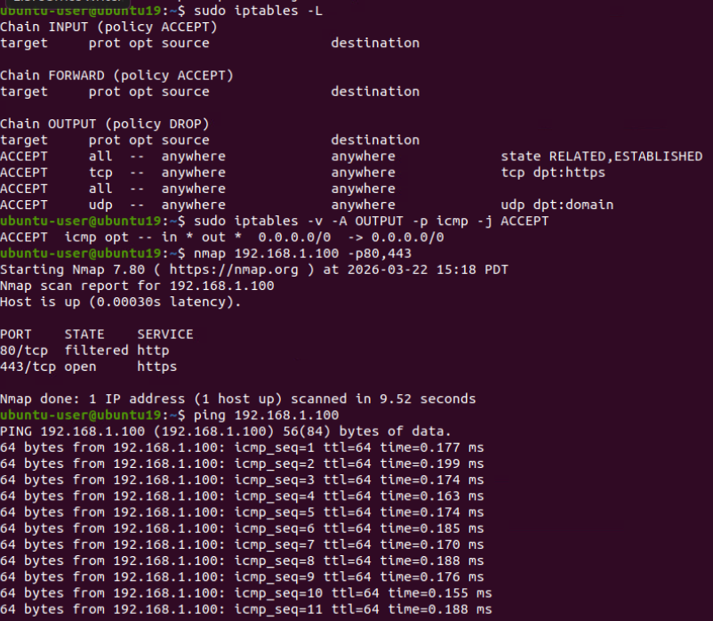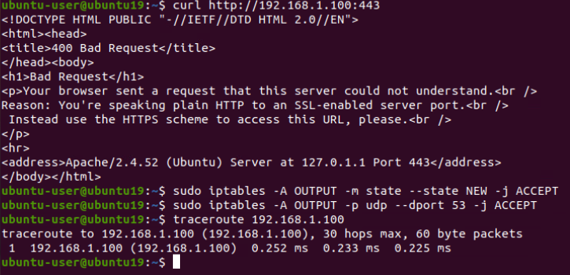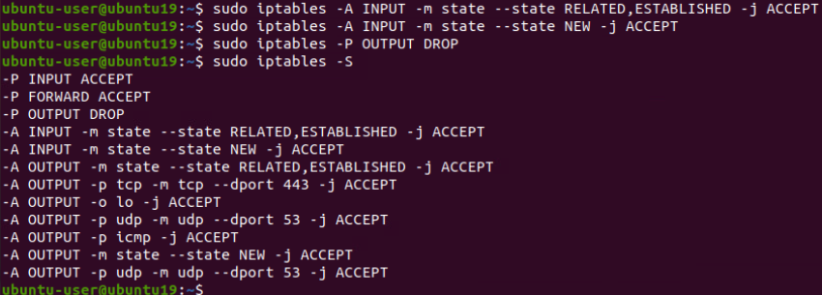

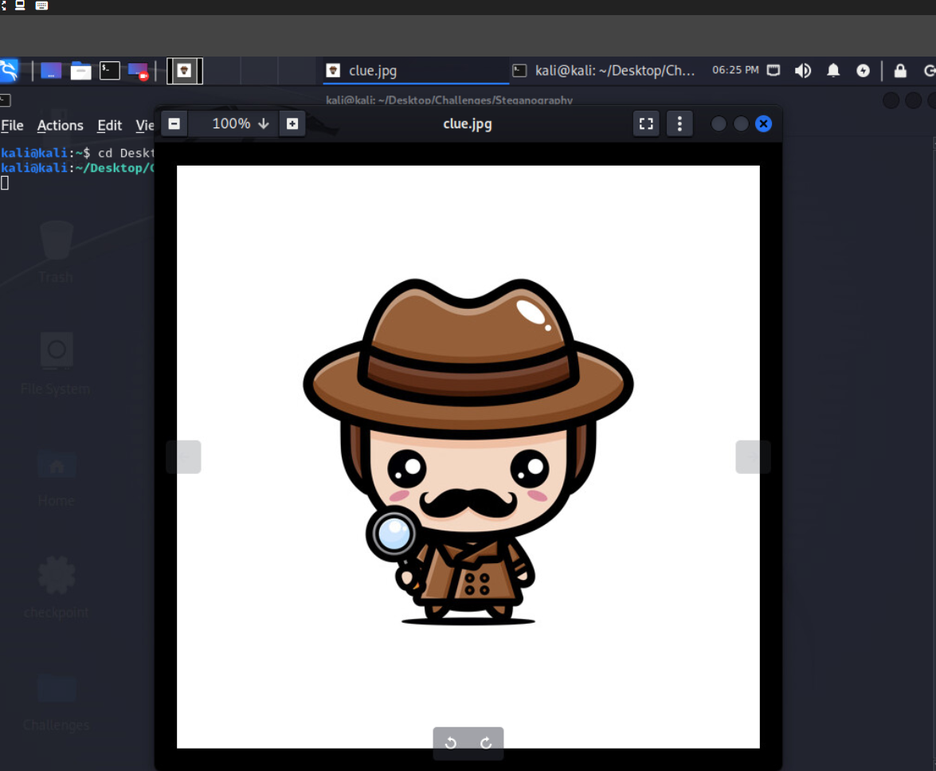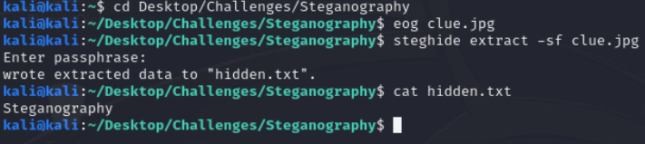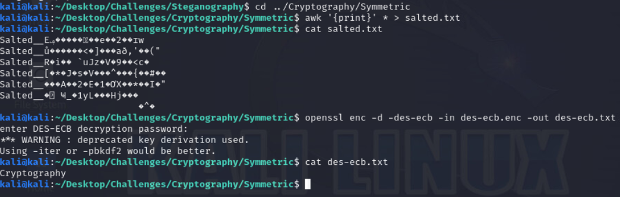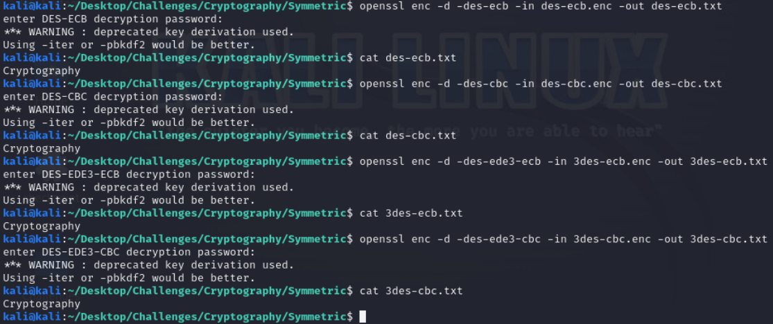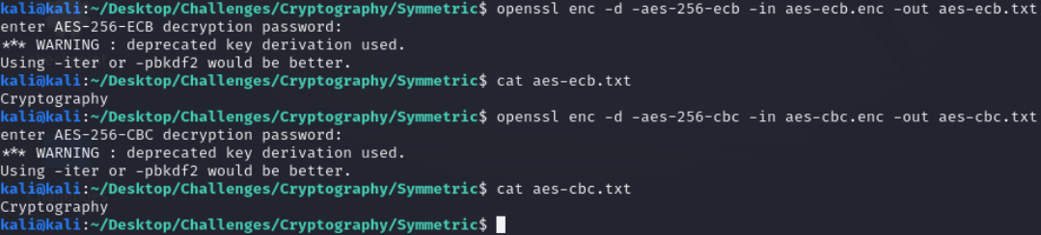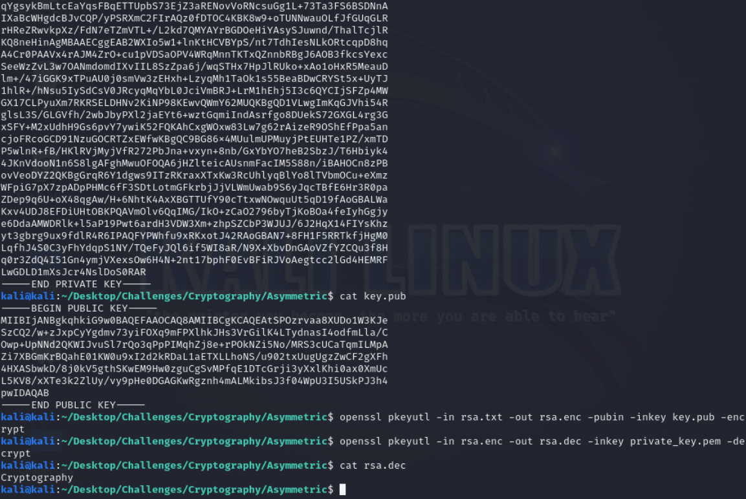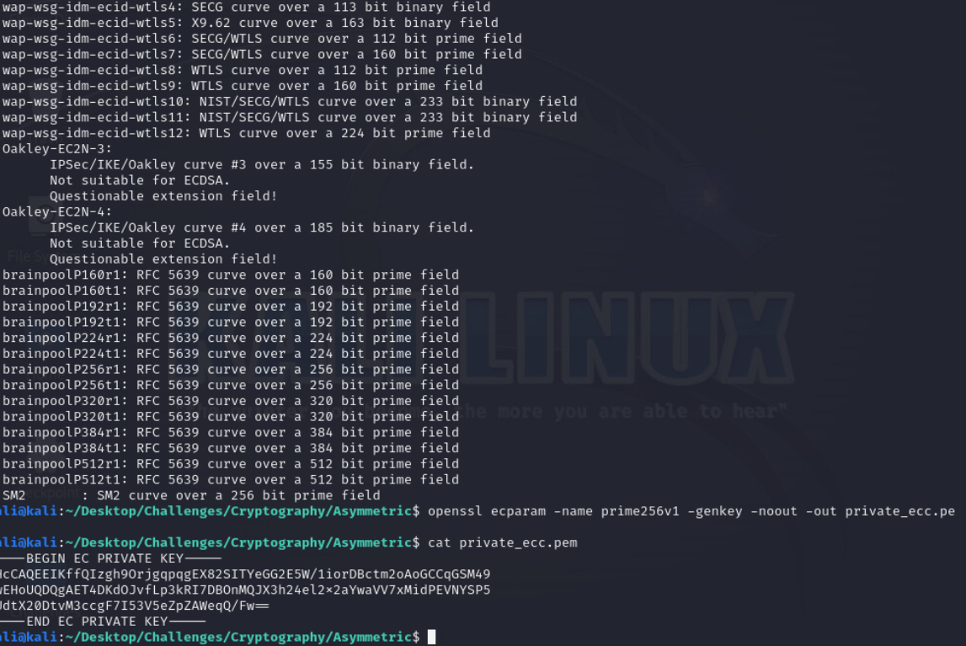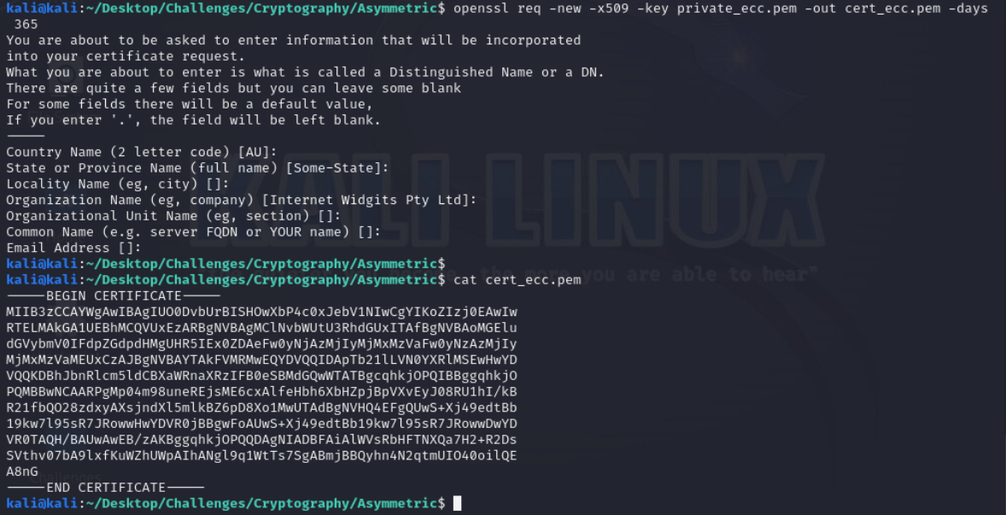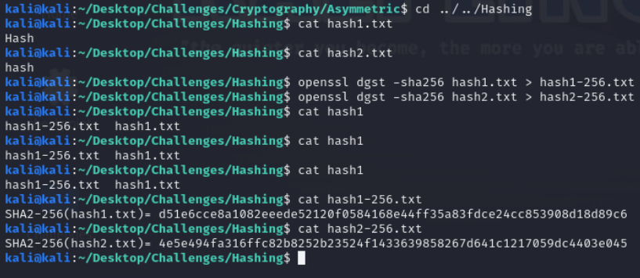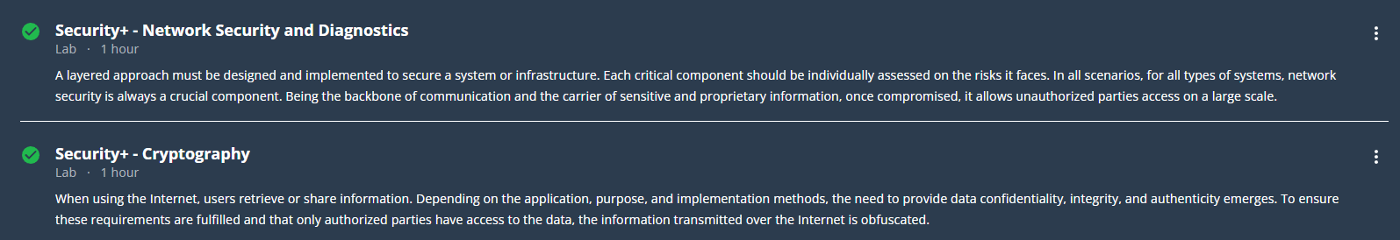

References
Cisco. (2023). What is a firewall? https://www.cisco.com/c/en/us/products/security/firewalls/what-is-a-firewall.html

Cloudflare. (2023). What is encryption? https://www.cloudflare.com/learning/ssl/what-is-encryption/

Cybersecurity and Infrastructure Security Agency. (2023). Encryption basics. https://www.cisa.gov/encryption

National Institute of Standards and Technology. (2023). Guidelines on Firewalls and Firewall Policy (SP 800-41 Rev.1). https://nvlpubs.nist.gov/nistpubs/Legacy/SP/nistspecialpublication800-41r1.pdf

